Operating Systems-Project

Group Members: Anshul Jain Y09UC027

Project Definition: To detect the independent sections i.e. the lines of code that can run concurrently from a given piece of code.

Assumptions: In this project we have made certain assumptions which are as follows:
- The names of the variables are of single character.
- The declarations and loops are assumed to begin from the first position of the line in which they are contained.
- The algorithm does not consider variable++ and ++variable and corresponding operators.
- The various data types that a variable can have are int, char, float and double.
- The algorithm has no provision for checking initialization of char type variables along with their declaration.
- The various loops covered in this project include only for, while and if.

Important points:
- There is a structure that has char name and int read and int write named variables. Every variable is made an object of this structure.
- There is a separate list maintained that contains names of all the variables encountered in the code.
- The loop do while will be treated the same as the while loop.
- The loops covered can contain any number of braces.
- With every variable there is an associated type at any particular instance. Either it can be a write or a read variable.
- There is a function named critical_section()that takes two arguments which are the name of the variable and its type. Depending on the arguments the functions returns an integral value which is the maximum of read and write values for that variable. Its working is given below.
- Whenever a line is read for the variables to be passed into the function critical_section() then blank spaces, arithmetic operators, conditional operators, braces etc are skipped. Only the single characters are read.
- Blocks are referred to as the group of instructions that will be executed at the same instance of time i.e. concurrently. The block number gives the order in which the blocks will be executed. For instance the first block to run will be block1, followed by block2 and so on.

Algorithm: The algorithm is such that we read the given code line by line and virtually fragment the code into various segments which include declaration and initialization, assignment, conditional statements and loops . For each line we check if it belongs to a particular segment and hence the procedures corresponding to a particular segment are performed. If it belongs to a particular segment then it is not checked for the other remaining segments. The procedures followed for different segments are as follows:
- Declaration and Initialization: We scan the code to find any occurrences of int, char, float and double. If a particular line is found to have occurrence of any of them then it is checked if the line is not a Declaration as well as an Initialization statement. If not then the variables are passed to the function critical_section() with their type as write. If the line is a declaration as well as an initialization statement then it is searched till the first occurrence of ‘=’ is encountered. All the variables before that are passed to the function critical_section() with their type write. All the variables after the ‘=’ till a ‘,’ is encountered are passed to the function critical_section() with their type as read. After that ‘,’ the line is again scanned and the process is repeated till the end of line is not encountered.
- Assignment: We scan the code to find any occurrences of ‘=’. If the line is found to have its occurrences then we read the line until the ‘=’ is not encountered. Until then all the variables are passed to the function critical_section() with their type as write. After the ‘=’ we pass all the variables until the ‘;’ is not encountered to the function critical_section() with their type as read.
- Conditional Statements: We scan the code to find any occurrences of if (. If the line is found to have any occurrences of it then it is read from if ( onwards until the last ‘)’ is not encountered. All the variables are passed to the function critical_section() with their type read.
- Loops: We scan the code to find any occurrences of for( or while( . If a line is found to have any occurrences then it is read until the last ‘)’ is not encountered. As far as for loop is concerned it is composed of variable initialization, conditional check and then variable assignment. We read the line until the first occurrence of ‘;’ is encountered. We classify the part from ( till ‘;’ to be a part of the assignment segment. Hence procedures corresponding to assignment segment are repeated on the first part of for statement. The next part is classified as to be belonging to conditional statements segment. So the procedures corresponding to conditional statements are performed. The next part is classified as to be belonging to assignment segment. Hence on the third part of for loop the procedures corresponding to assignment segment are called on. As far as while loop is concerned the procedure for conditional statements is called upon and all the variables are passed with their type as read.
After each check on a particular line for a particular segment all the read and write values of the variables involved in that line are modified to the initial values.

Order of classification: Given any statement it is checked for the segments to which it belongs but the order of classification is the most important. Once a statement is found to be belonging to a particular segment then it is not checked for belonging to other segments. The order is as follows:
  - Declarations and initialization
  - For Loop
  - Conditional statements i.e. if and while loops
  - Assignment i.e. arithmetic operations

The function critical_section(): It takes two arguments viz. variable name and variable type. If a variable is of read type and is found to be present in the list then this function returns the present write value of the variable incremented by one. If a variable is of write type and is found in the list then this function returns the maximum of read and write values of the variable incremented by one. If the variable is of any type and not found on the list then the list is updated to include this variable making its read and write values both equal to one.

Main Step: Given any instruction after all the analysis we assign it a block no. The block number for any instruction is decided by the maximum of the returned values of the function critical_section() for every variable present in that line. All the statements in a given block are independent of each other and depend on those of the previous block.

Software and Tools used: Programming language: C
Compiler: GCC in LINUX
Goals: The blocks hence achieved are composed of independent statements. We can multithread the statements in any particular block and hence achieve high performance and low execution time in a multi processor environment. Although for small pieces of code the execution time of the original program is less than that of the process following our algorithm but we hope for large sections of code it may turn out to be more fruitful in terms of execution time.

Tasks unaccomplished: Although we were able to design the algorithm but have not implemented the following things:
- Function calls: If we call a function with n number of parameters then we go to the function definition and check whether any of the variable is being modified or not. If a variable is being modified then we will treat it as a write variable and others as read variables.

Snapshots:
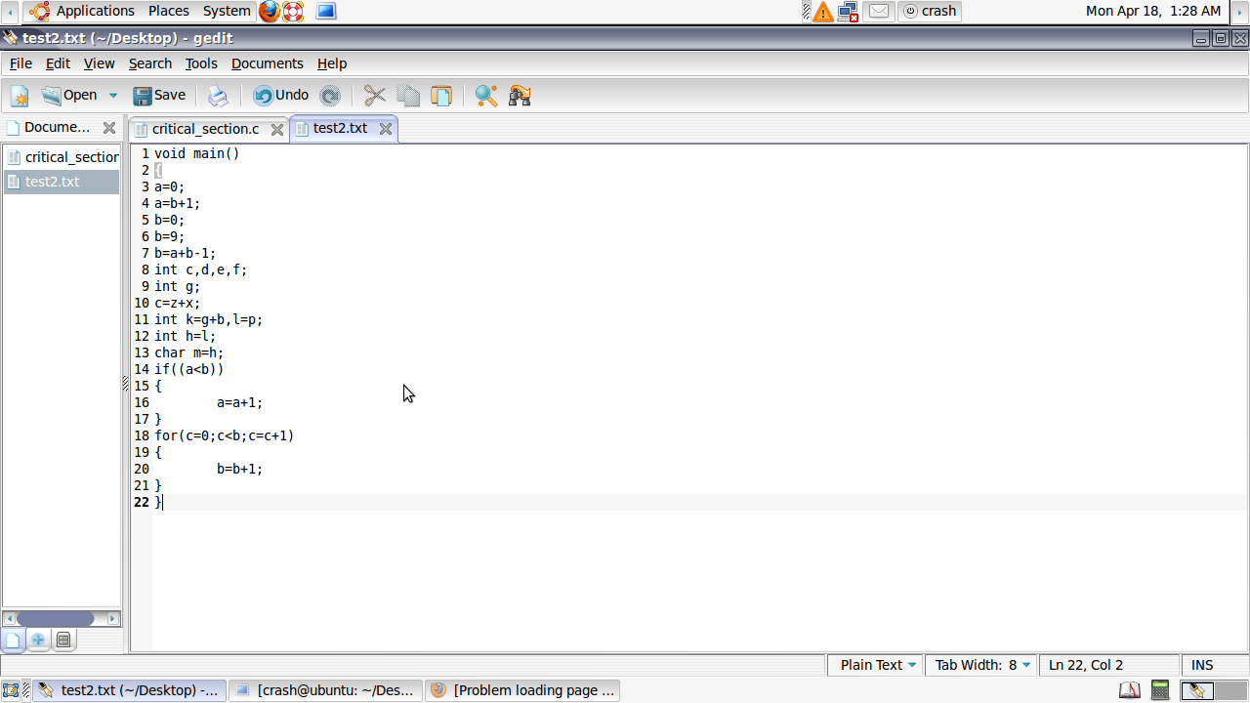

Input code file

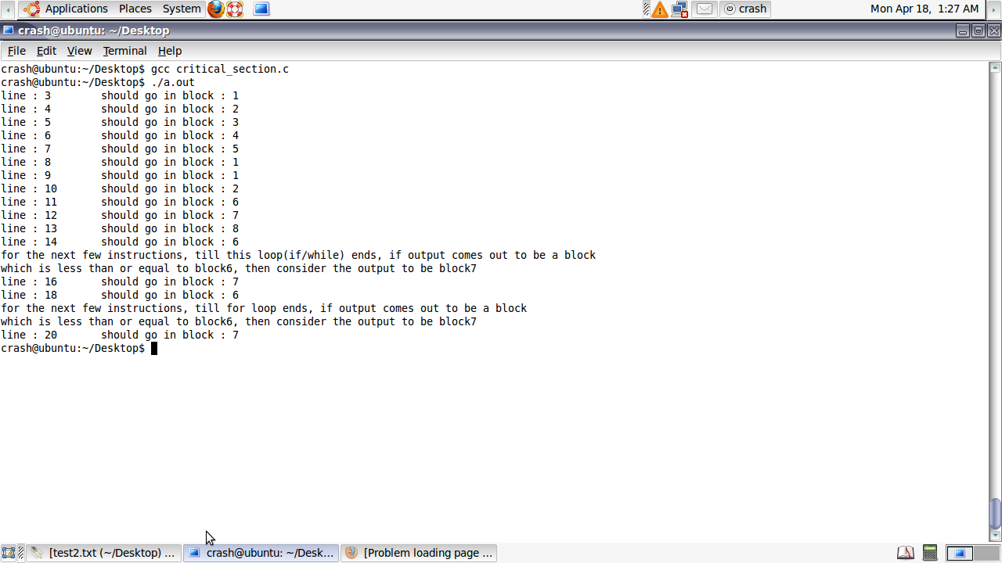

Output

